School Newsletter Autumn Term 1 2026
Watermill School


Dates for your diary
Friday 27th March 2026

School closes for Easter at 2.30pm

Monday 13th April 2026
School re-opens at 8.30am

Monday 4th May 2026
School closed- Bank Holiday

Friday 22nd May 2026
School Closes at 2.30pm for half-term.

Monday 1st June 2026
School reopens at 8.30am

Saturday 11th July 2026

Summer Extravaganza


If you have any concerns about your child’s attendance, please contact school on 01782 883737.
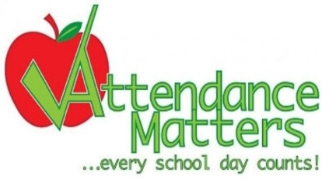

Dear Parents and Carers,
It is lovely to have some good weather at the end of a damp, cold term!
However, the weather hasn't stopped our pupils from taking part in a wide range of activities including visits to Trentham Gardens, Our Space, the cinema and in school sports events.
Our theme has been “Spring is in the Air”, and I have seen some lovely work in the classrooms relating to our topic. Pupils have made great use of our horticulture areas, sensory rooms and sensory garden.
We have been holding several fundraising events, and I want to add a big thank you to our parents' group and to Phil Taylor for all the support given. We are now fundraising for playground equipment.
We have recently had a review of our new curriculum, and you can find links to the curriculum documents on our website.
The new Watermill Brindley site is progressing well, and we should have our handover in July.
I hope you have a wonderful Easter Holiday. Thank you for your ongoing support.
Best Wishes
Mrs Jen Lomas
Head Teacher
Service Children
If there are any parents that are in the armed forces, could you please let the school know.
Summer Extravaganza!
Saturday 11th July, 11am to 3pm. It is free entry and the theme is “Watermill at the Beach”. There are stalls, a bouncy castle, face painting, refreshments and more.


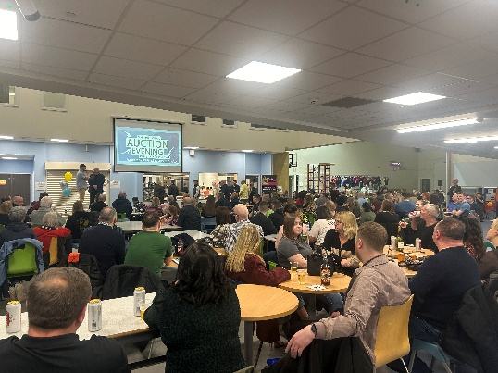
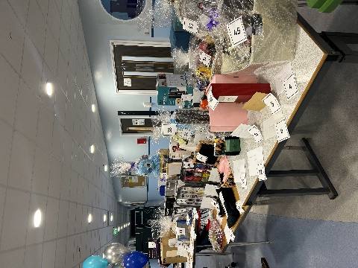
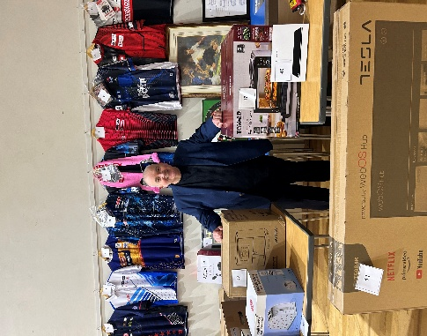


World Book Day
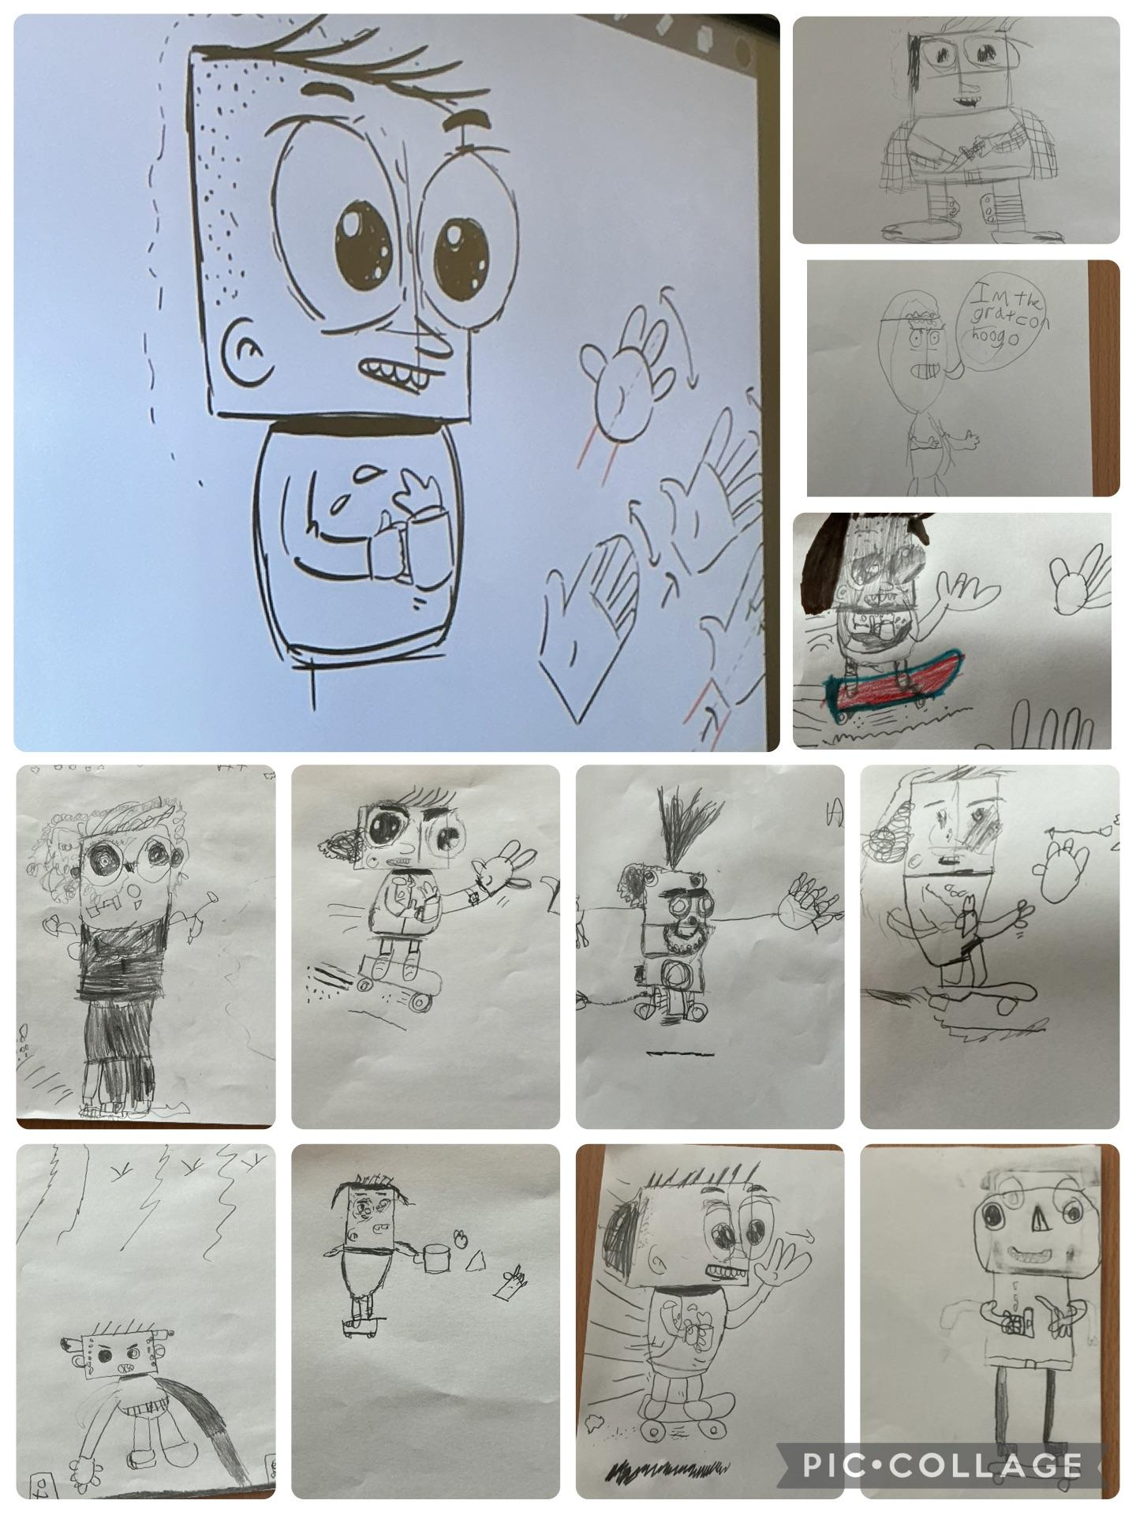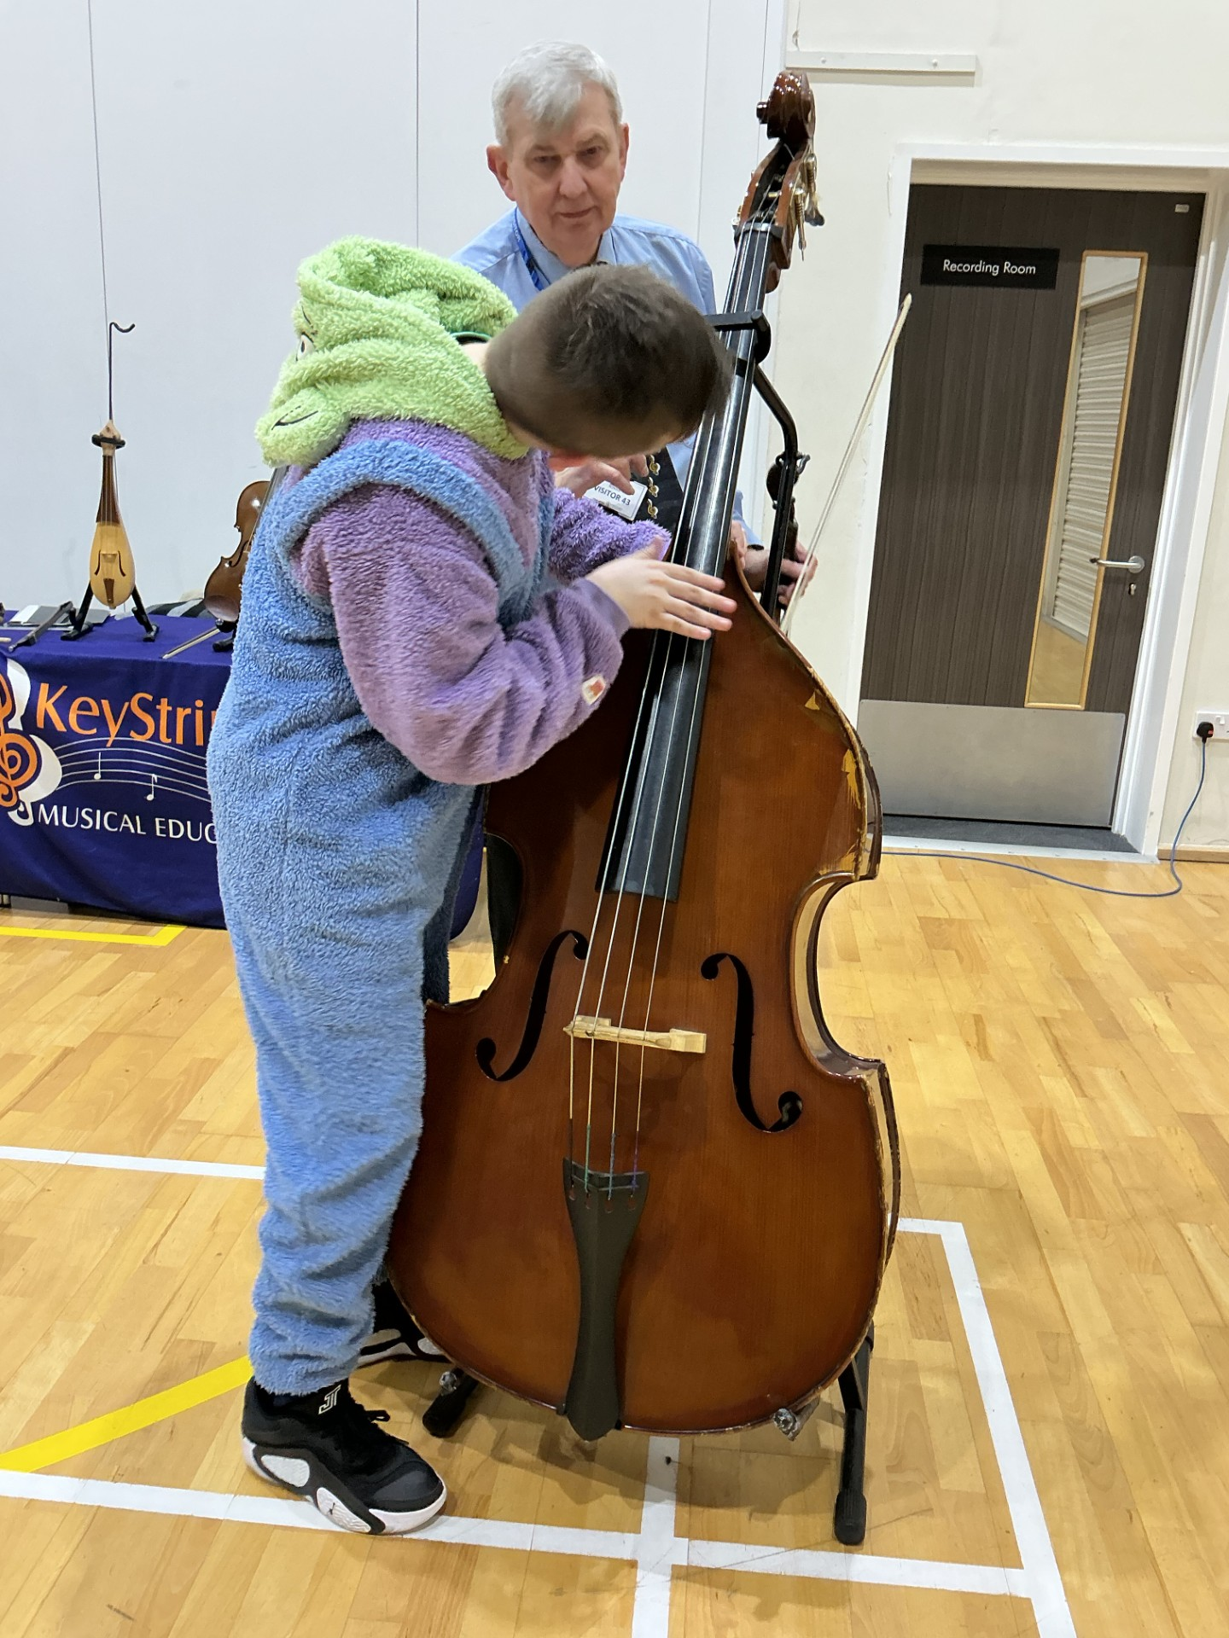
World Book Day was a wonderful celebration across the school, with every child engaging in stories in the way that suits them best. From our lively ‘Masked Reader’ gameshow, where pupils guessed the staff behind the masks, to a creative visit from cartoonist Chris Altham and lots of excitement across the school.

We also enjoyed a fantastic session with Key Strings, where pupils listened to music from well-known stories and explored a range of stringed instruments up close.

A big hit this year were our new Tonie boxes, which opened audio storytelling for many pupils who haven’t previously engaged with books. It was lovely to see them absorbed in stories in a new and accessible way.
Across the school, staff delivered a range of sensory stories, and our older pupils even created and shared their own with younger classes. Their confidence and creativity shone, and the younger pupils were fully engaged.
It was a brilliant week that reminded us that stories can be enjoyed in so many ways, and we are incredibly proud of all our pupils.
Happy Easter

Phil Taylor’s Auction Evening
What a fantastic Auction Night we had! Thank you to everyone who joined us for an evening filled with excitement, friendly competition, and incredible generosity. The atmosphere was buzzing from start to finish, with a wonderful turnout and some truly impressive bids. We are delighted to share that the event was a great success, not only in raising funds, but also in bringing our community together. Your support made the night memorable, and we are deeply grateful to all who contributed, volunteered, or took part in any way. Total amount raised was £12,000!

